**Mortgages in U.S banking sector**

Mortgages in the U.S. banking sector are a fundamental component of the financial system, providing a means for individuals to purchase homes and for banks to generate revenue through interest and fees.

**Types of Mortgages**

1. **Fixed-Rate Mortgages**: The interest rate remains the same for the entire term of the loan, typically 15 or 30 years.
2. **Adjustable-Rate Mortgages (ARMs)**: The interest rate can change periodically, typically in relation to an index, which may cause payments to go up or down.
3. **Government-Backed Mortgages**: These include loans insured or guaranteed by the federal government, such as FHA loans, VA loans, and USDA loans.
4. **Jumbo Mortgages**: Loans that exceed the conforming loan limits set by the Federal Housing Finance Agency (FHFA). These are often used for high-value properties.

**Key Players**

1. **Commercial Banks**: Major banks like Wells Fargo, Bank of America, and JPMorgan Chase are significant players in the mortgage market, offering a wide range of mortgage products.
2. **Mortgage Brokers**: They act as intermediaries between borrowers and lenders, helping to find the best mortgage terms for the borrower.
3. **Credit Unions**: These member-owned institutions also provide mortgage products, often at competitive rates.
4. **Government-Sponsored Enterprises (GSEs)**: Fannie Mae and Freddie Mac buy mortgages from lenders and either hold them in their portfolios or package the loans into mortgage-backed securities (MBS).

**Process**

1. **Application**: The borrower submits a mortgage application with financial information.
2. **Underwriting**: The lender assesses the borrower’s ability to repay the loan, including credit history, income, debt levels, and the value of the property.
3. **Approval**: If approved, the loan moves to closing, where terms are finalized, and the borrower signs the mortgage note.
4. **Servicing**: The lender or a third party collects payments from the borrower and handles administrative tasks related to the loan.

**Interest Rates and Economic Impact**

* **Interest Rates**: Mortgage rates are influenced by the Federal Reserve's monetary policy, economic conditions, and the bond market. Lower rates typically spur more borrowing and home buying, while higher rates can dampen demand.
* **Economic Indicators**: The health of the mortgage market is often seen as a reflection of the broader economy. High default rates can signal economic distress, while robust mortgage activity can indicate economic growth.

**Regulatory Environment**

1. **Dodd-Frank Act**: Implemented after the 2008 financial crisis, this act aims to reduce risks in the financial system and includes the creation of the Consumer Financial Protection Bureau (CFPB).
2. **CFPB**: This agency oversees and enforces consumer protection laws, ensuring fair treatment of borrowers.
3. **Community Reinvestment Act (CRA)**: Encourages banks to meet the credit needs of all segments of their communities, including low- and moderate-income neighborhoods.

**Current Trends**

1. **Digital Mortgages**: Increasing use of technology for mortgage applications, underwriting, and servicing.
2. **Refinancing Booms**: Occur when interest rates drop significantly, prompting many homeowners to refinance their existing mortgages.
3. **Housing Market Dynamics**: Supply and demand in the housing market can influence mortgage activity, with high demand and low supply driving up home prices and mortgage amounts.

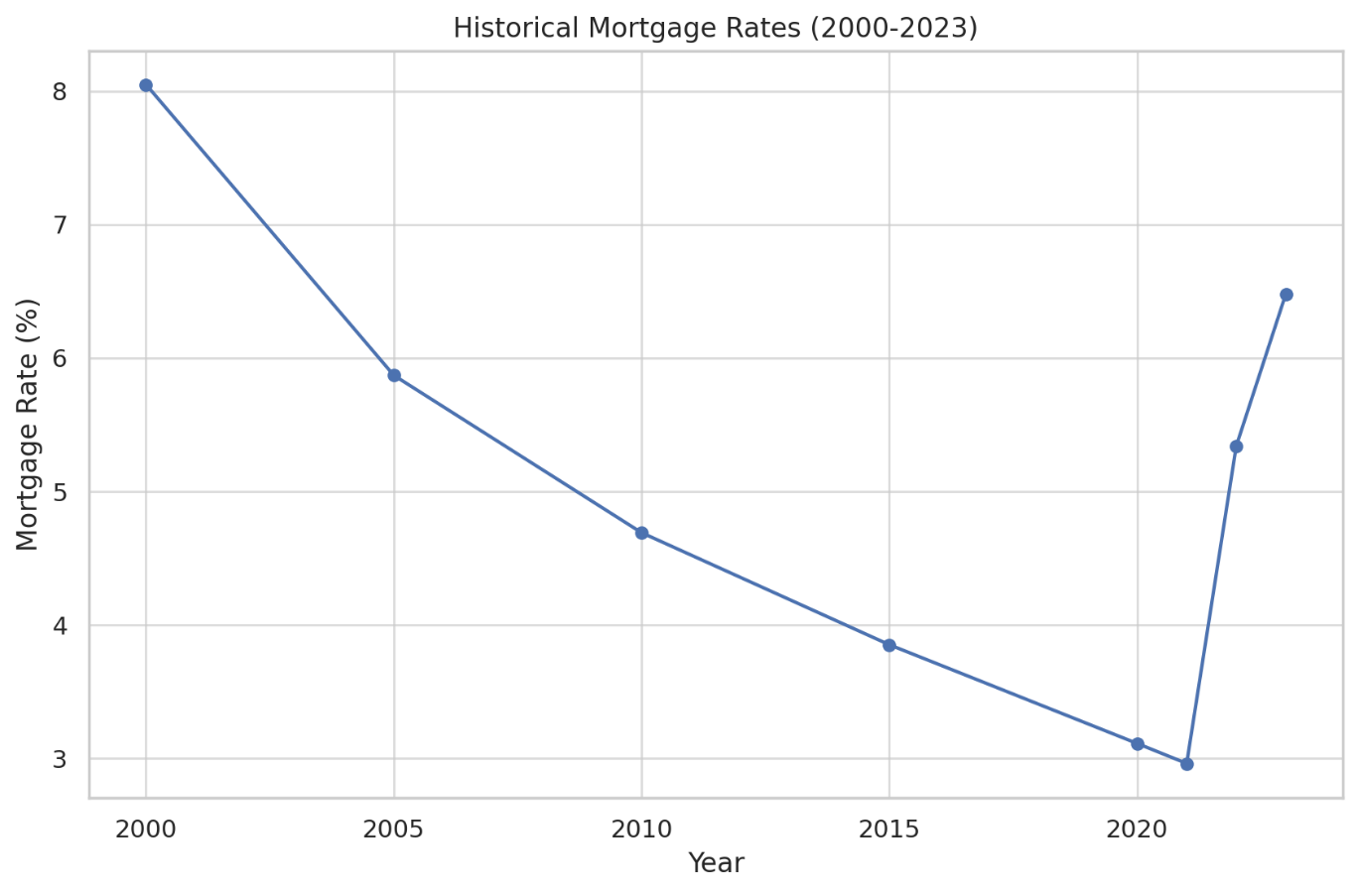

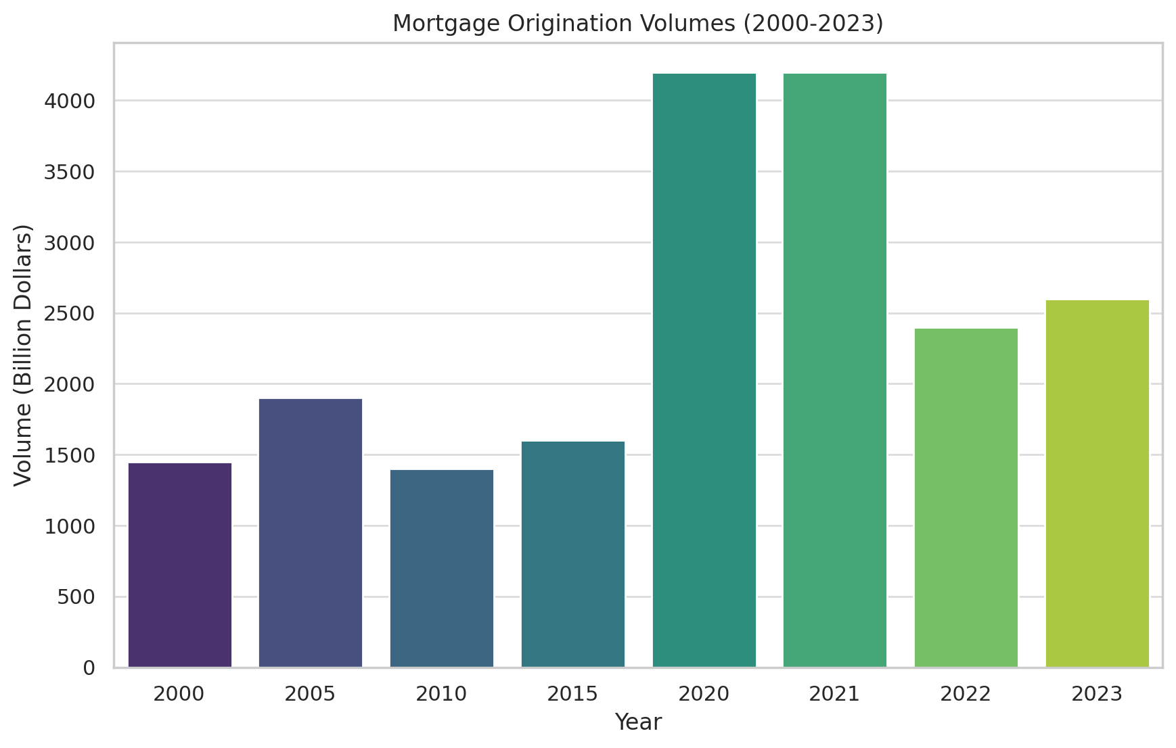

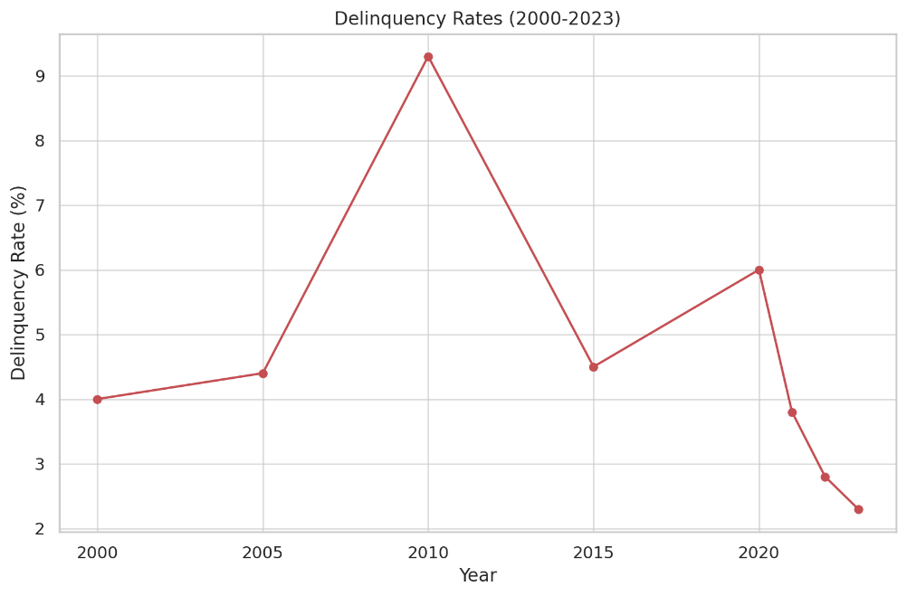

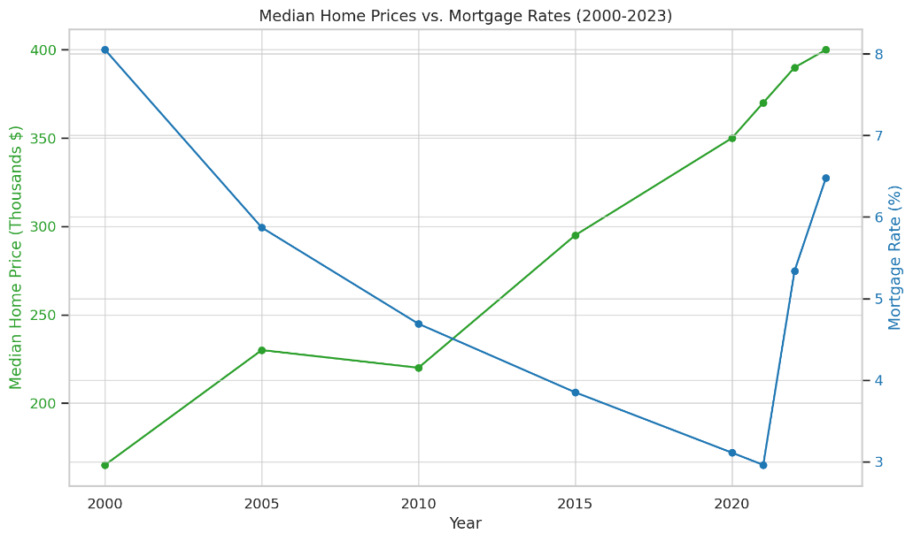

**Key Statistics**

1. **Historical Mortgage Rates**:
   * Mortgage rates have significantly fluctuated over the past two decades, peaking at 8.05% in 2000 and hitting a low of 2.96% in 2021.
   * Recently, rates have risen again to 6.48% in 2023.
2. **Mortgage Origination Volumes**:
   * Mortgage originations saw a substantial increase during the housing boom, reaching $1.9 trillion in 2005.
   * A significant surge occurred in 2020 and 2021, with volumes reaching $4.2 trillion each year, largely due to low interest rates and refinancing activities.
   * In 2023, the volume decreased to $2.6 trillion, reflecting rising interest rates.
3. **Delinquency Rates**:
   * Delinquency rates peaked at 9.3% in 2010, following the financial crisis of 2008.
   * Rates have steadily decreased since then, reaching 2.3% in 2023, indicating improved economic conditions and lending practices.
4. **Median Home Prices vs. Mortgage Rates**:
   * Median home prices have generally trended upward, from $165,000 in 2000 to $400,000 in 2023.
   * There is an inverse relationship between mortgage rates and home prices: lower mortgage rates in recent years have coincided with rising home prices.
   * As mortgage rates increased in 2022 and 2023, the rate of increase in home prices has slowed down.

**Managing mortgages in the face of market fluctuations is a complex task that involves strategies from both lenders (banks, credit unions, mortgage brokers) and borrowers.**

**Lenders' Strategies**

1. **Interest Rate Adjustments**:
   * **Adjustable-Rate Mortgages (ARMs)**: Lenders offer ARMs, where interest rates can be adjusted periodically based on market indices. This allows them to align the interest rates with the current market conditions.
   * **Fixed-Rate Mortgages**: For fixed-rate mortgages, lenders may adjust the rates offered to new borrowers based on current and anticipated future interest rates set by the Federal Reserve and the overall economic outlook.
2. **Credit Underwriting Standards**:
   * During times of economic uncertainty, lenders may tighten credit standards, requiring higher credit scores, larger down payments, and more comprehensive income verification.
   * Conversely, in a booming economy, they might loosen these standards to attract more borrowers.
3. **Mortgage Servicing**:
   * **Loan Modifications**: Lenders may offer loan modifications to borrowers who are struggling to keep up with payments due to economic downturns. This can include reducing interest rates, extending loan terms, or temporarily deferring payments.
   * **Foreclosure Management**: In severe cases, lenders may proceed with foreclosures, though this is generally a last resort due to the associated costs and potential loss of value.
4. **Diversification of Mortgage Products**:
   * Lenders may offer a variety of mortgage products to cater to different market conditions, such as interest-only loans, balloon mortgages, and hybrid ARMs.
5. **Hedging and Financial Instruments**:
   * Lenders use financial derivatives and hedging strategies to manage the risk associated with interest rate fluctuations. This can include interest rate swaps, futures, and options.

**Borrowers' Strategies**

1. **Refinancing**:
   * Borrowers often refinance their mortgages to take advantage of lower interest rates. This can reduce monthly payments or shorten the loan term.
   * Refinancing can also be used to switch from an adjustable-rate mortgage to a fixed-rate mortgage for more predictable payments.
2. **Rate Locks**:
   * When applying for a mortgage, borrowers can lock in an interest rate to protect against future rate increases during the loan processing period.
3. **Adjustable-Rate Mortgages (ARMs)**:
   * In a low-interest-rate environment, borrowers might choose ARMs to benefit from lower initial rates, with the expectation that they can refinance or adjust their financial situation before rates increase.
4. **Down Payment Adjustments**:
   * To mitigate the impact of fluctuating interest rates, borrowers might increase their down payment to reduce the loan amount and monthly payments.
5. **Financial Planning and Budgeting**:
   * Borrowers manage their finances by budgeting for potential rate increases, especially if they have ARMs. They might also build emergency funds to cover unexpected changes in mortgage payments.

**Regulatory and Government Support**

1. **Government Programs**:
   * Programs like the Home Affordable Refinance Program (HARP) and the Home Affordable Modification Program (HAMP) were introduced to help borrowers refinance or modify their loans during the financial crisis.
   * The Federal Housing Administration (FHA), Veterans Affairs (VA), and the U.S. Department of Agriculture (USDA) offer government-backed loans that provide more favorable terms during economic downturns.
2. **Monetary Policy**:
   * The Federal Reserve influences mortgage rates through its monetary policy. By adjusting the federal funds rate, the Fed indirectly impacts the interest rates that banks charge for mortgages.
3. **Consumer Protection Laws**:
   * The Consumer Financial Protection Bureau (CFPB) ensures that lenders provide transparent information and fair terms to borrowers, helping them make informed decisions even during market fluctuations.

These strategies help both lenders and borrowers manage the risks and opportunities presented by market fluctuations, ensuring the stability and resilience of the mortgage market.

**key players in the mortgage market and the specific products they offer:**

**Commercial Banks**

1. **Wells Fargo**
   * **Fixed-Rate Mortgages**: Offers stable monthly payments for the life of the loan, typically available in 15, 20, and 30-year terms.
   * **Adjustable-Rate Mortgages (ARMs)**: Initial lower rates for a specified period, then adjusting periodically based on market conditions.
2. **Bank of America**
   * **FHA Loans**: Government-backed loans with lower down payment requirements.
   * **Jumbo Loans**: For properties exceeding conforming loan limits, often used for high-value properties.
3. **Chase Bank**
   * **VA Loans**: Loans guaranteed by the Department of Veterans Affairs, offering favorable terms for veterans and active-duty military personnel.
   * **Dreamaker Mortgage**: Offers down payments as low as 3% and reduced mortgage insurance requirements.

**Credit Unions**

1. **Navy Federal Credit Union**
   * **Military Choice Loans**: For military members with low down payment options and no private mortgage insurance (PMI) requirement.
   * **Home Buyers Choice Loan**: No PMI and zero down payment for first-time homebuyers.
2. **PenFed Credit Union**
   * **Adjustable-Rate Mortgages (ARMs)**: Competitive initial rates that adjust periodically.
   * **Fixed-Rate Mortgages**: Offers terms ranging from 10 to 30 years with fixed monthly payments.

**Mortgage Brokers**

1. **Quicken Loans (Rocket Mortgage)**
   * **Customizable Loan Options**: Offers a wide range of mortgage products with personalized loan terms and interest rates.
   * **Streamlined Online Application**: Simplified digital application process with quick approvals.
2. **Loan Depot**
   * **Home Improvement Loans**: Tailored loans for home renovation and improvements.
   * **Refinancing Options**: Offers various refinancing products to lower monthly payments or cash out home equity.

**Government-Sponsored Enterprises (GSEs)**

1. **Fannie Mae**
   * **HomeReady Mortgage**: Designed for low- to moderate-income borrowers, with flexible down payment options.
   * **Conventional 97 Loan**: Allows down payments as low as 3% for first-time homebuyers.
2. **Freddie Mac**
   * **Home Possible® Mortgage**: Low down payment options for borrowers with low-to-moderate income.
   * **HARP (Home Affordable Refinance Program)**: Helps homeowners refinance their mortgage even if they owe more than the home’s current value.

**Government Agencies**

1. **Federal Housing Administration (FHA)**
   * **FHA Loans**: Insured loans with low down payment requirements, popular among first-time homebuyers.
2. **Department of Veterans Affairs (VA)**
   * **VA Loans**: Loans with no down payment, no PMI, and competitive interest rates, available to veterans, active-duty service members, and eligible surviving spouses.
3. **U.S. Department of Agriculture (USDA)**
   * **USDA Rural Development Loans**: Loans for low-to-moderate-income individuals in rural areas, offering no down payment and low interest rates.

**Examples of Mortgage Products**

* **Fixed-Rate Mortgages**: Offered by virtually all lenders, providing stable monthly payments for the life of the loan.
* **Adjustable-Rate Mortgages (ARMs)**: Commonly offered by banks like Wells Fargo and credit unions like PenFed.
* **Government-Backed Loans**: Available through commercial banks, credit unions, and government agencies like FHA, VA, and USDA.
* **Jumbo Loans**: Offered by institutions like Bank of America and Quicken Loans for high-value properties.
* **Refinancing Options**: Available from most lenders, including Loan Depot and Rocket Mortgage, to lower interest rates or access home equity.